**S.Y.B.Tech**

**Computer Engineering**

**Lab. : CE 2207 Operating Systems Laboratory (OSL)**

**------------------------------------------------------------------------------------------------**

|  |  |
| --- | --- |
| **Assignment #1: (Group-‘B6’)**   |  | | --- | |  |   **Title:** Write a program to implement following disk scheduling algorithms: First Come First Serve (FCFS), Shortest Seek Time First (SSTF) |

**Objective:** Implementation of disk scheduling algorithms.

**Theory:**

Disk scheduling is done by operating systems to schedule I/O requests arriving for disk. Disk scheduling is also known as I/O scheduling.

Disk scheduling is important because:

* Multiple I/O requests may arrive by different processes and only one I/O request can be served at a time by disk controller. Thus other I/O requests need to wait in waiting queue and need to be scheduled.
* Two or more request may be far from each other so can result in greater disk arm movement.
* Hard drives are one of the slowest parts of computer system and thus need to be accessed in an efficient manner.

There are many Disk Scheduling Algorithms but before discussing them let’s have a quick look at some of the important terms:

* Seek Time: Seek time is the time taken to locate the disk arm to a specified track where the data is to be read or write. So the disk scheduling algorithm that gives minimum average seek time is better.
* Rotational Latency: Rotational Latency is the time taken by the desired sector of disk to rotate into a position so that it can access the read/write heads. So the disk scheduling algorithm that gives minimum rotational latency is better.
* Transfer Time: Transfer time is the time to transfer the data. It depends on the rotating speed of the disk and number of bytes to be transferred.
* Disk Access Time: Disk Access Time is sum of Seek Time, Rotational Latency and Transfer Time

Disk Scheduling Algorithms:

1. FCFS: First Come First Serve (FCFS) is the simplest of all the Disk Scheduling Algorithms. In FCFS, the requests are addressed in the order they arrive in the disk queue.

**Advantages:**

* + - Every request gets a fair chance
    - No indefinite postponement

**Disadvantages:**

* + - Does not try to optimize seek time
    - May not provide the best possible service

1. SSTF: In SSTF (Shortest Seek Time First), requests having shortest seek time are executed first. So, the seek time of every request is calculated in advance in queue and then they are scheduled according to their calculated seek time. As a result, the request near the disk arm will get executed first. SSTF is certainly an improvement over FCFS as it decreases the average response time and increases the throughput of system.

**Advantages:**

* + - Average Response Time decreases
    - Throughput increases

**Disadvantages:**

* + - Overhead to calculate seek time in advance.
    - Can cause Starvation for a request if it has higher seek time as compared to incoming requests
* **Example:** We illustrate them with a request queue (0-199).

98, 183, 37, 122, 14, 124, 65, 67 and Head pointer 53

* 1. **FCFS:**

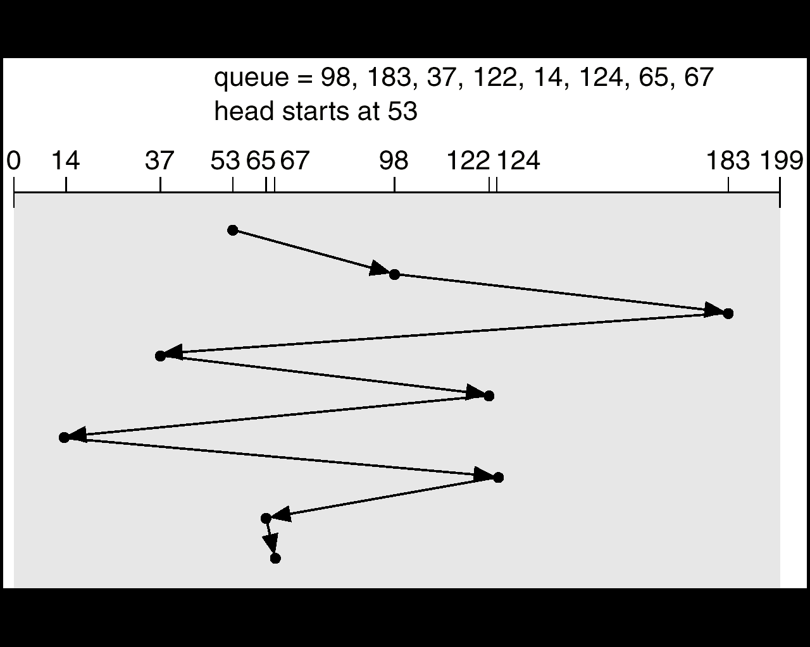

**FCFS ALGORITHM:**

1. Input the maximum number of cylinders and work queue and its current header position.
2. First Come First Serve Scheduling (FCFS) algorithm– The operations are performed in order requested, starting from the current header position.
   1. There is no reordering of work queue.
   2. Every request is serviced, so there is no starvation.
   3. The seek time is calculated
   4. **SSTF:**

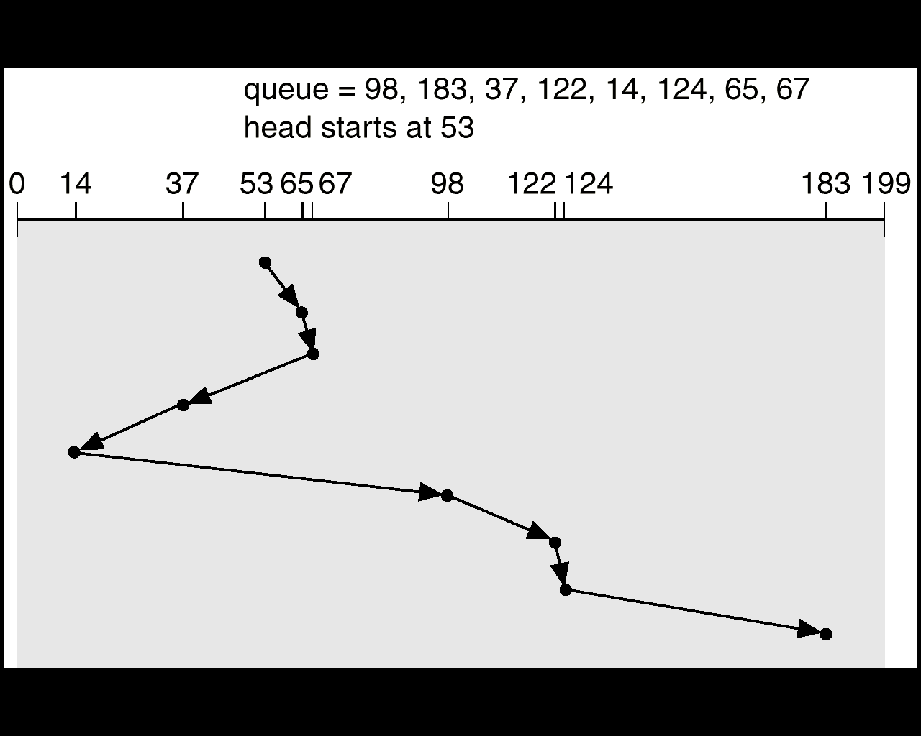

**SSTF** **ALGORITHM**:

1. Shortest Seek Time First Scheduling (SSTF) algorithm– This algorithm selects the request with the minimum seek time from the current head position.

2. Since seek time increases with the number of cylinders traversed by the head, SSTF chooses the pending request closest to the current head position.

3. The seek time is calculated.

**Sample Output:**

Enter maximum number of cylinders: 200

Enter total number of cylinders to be accessed: 5

Enter the sequence of cylinders: 23, 89, 132, 42, 187

Enter starting location of head: 100

Sequence is:

23 89 132 42 187 100

Starting location of head: 100

Maximum number of cylinders: 200

***DISK SCHEDULING***

1) First Come, First Serve (FCFS)

2) Shortest-Seek-Time-First (SSTF)

3) Exit menu

Enter your choice: 1

Distance calculation:

100-23=77

89-23=66

132-89=43

42-132=90

187-42=145

Total distance travelled by head = 421

***DISK SCHEDULING***

1) First Come, First Serve (FCFS)

2) Shortest-Seek-Time-First (SSTF)

3) Exit menu

Enter your choice: 4

Minimum distance is 11 for disk number 89

Minimum distance is 43 for disk number 132

Minimum distance is 55 for disk number 187

Minimum distance is 145 for disk number 42

Minimum distance is 19 for disk number 23

Distance calculation:

|89-100|=11

|132-89|=43

|187-132|=55

|42-187|=145

|23-42|=19

Total distance traveled by head is: 273

***DISK SCHEDULING***

1) First Come, First Serve (FCFS)

2) Shortest-Seek-Time-First (SSTF)

3) Exit menu

Enter your choice: 3

Invalid Choice!!!

***(Note: You can use Java Collection Framework (JCF) (eg: Array list) to implement this assignment.)***